**S3 detail of data generation and quality analysis**

We choose a trustworthy deterministic physics software CORCA-3D to generate such a scale of data. Based on the real reactor scheme of a typical PWR. Specifically, 100,000 non-repetitive random core schemes are generated. The core scheme is arranged on a radial plane with 177 cuboid fuel assemblies, and put in a 15 ×15 chessboard-like matrix. For the safety requirement of power distribution balance, all fuel assemblies are rotationally symmetric around the center assembly. The 100,000 dataset are named D and are divided into training and testing set an 8 : 2 ratio.

To prevent the impact of inconsistent dimensions of initial burnup, fuel assembly types, and other factors, the present study employs the Min-Max normalization method to normalize the inputs and outputs of the neural network. The normalization formula is shown as Equation (3):



where Xnorm represents the normalized data, Xdata denotes the original data, Xmin and Xmax refer to the minimum and maximum values within the original data, respectively.

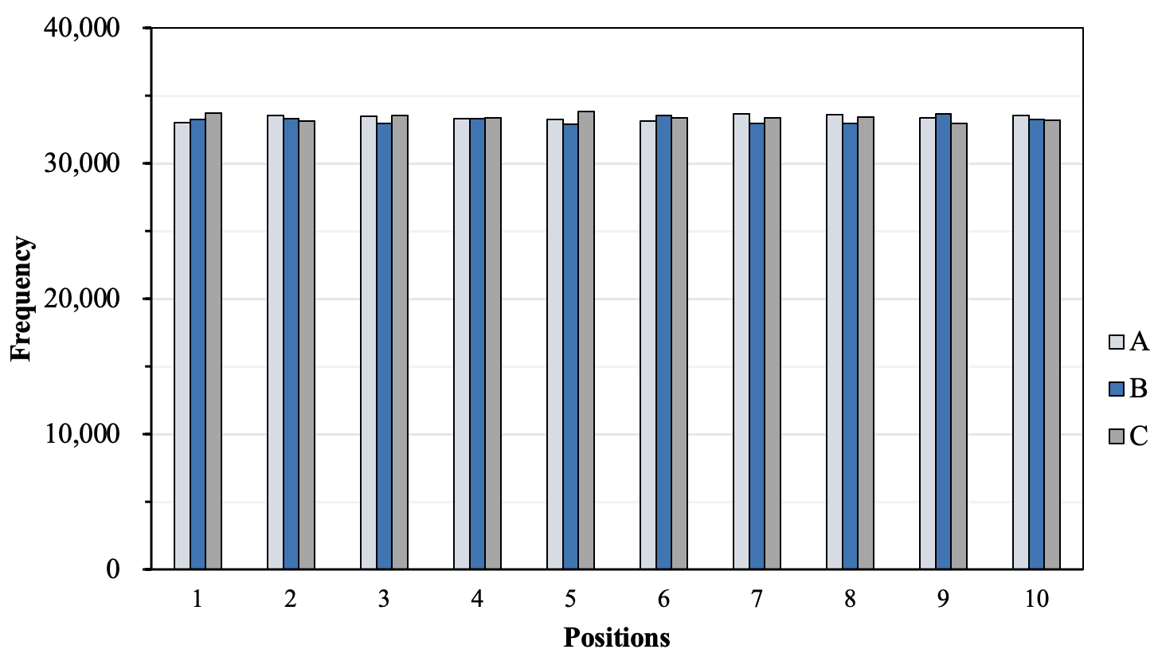

**Fig. 2**: Trend analysis of the frequency of three types at 10 positions.

**Table 1**: Frequency statistic of three types fuels at random 10 positions.

|  |  |  |  |
| --- | --- | --- | --- |
| Position  Types | α | β | γ |
| 1 | 32,995 | 33,251 | 33,754 |
| 2 | 33,526 | 33,313 | 33,161 |
| 3 | 33,494 | 32,984 | 33,522 |
| 4 | 33,322 | 33,326 | 33,352 |
| 5 | 33,281 | 32,902 | 33,817 |
| 6 | 33,125 | 33,523 | 33,352 |
| 7 | 33,671 | 32,972 | 33,357 |
| 8 | 33,603 | 32,943 | 33,454 |
| 9 | 33,366 | 33,672 | 32,962 |
| 10 | 33,552 | 33,232 | 33,216 |

**Analysis for inputs.** To ensure that the randomly generated core arrangement has low dispersion and does not exhibit preference features, the quality of dataset needs to be analyzed. The occurrence frequencies of three types α , β and γ are counted at 10 asymmetric positions of the core scheme, in order to observe whether there is any preference feature. The results are shown in Table 1 and Figure 1.

As can be seen from Table 1 and Figure 1, among the 10 asymmetric position, the highest value is 33,817 times, the lowest one is 32,902 times, and all the occurrence times are near to the average value. The maximum deviation from the mean value is about 1.45%, which proves that the overall dispersion of the data set is small. In the whole random scheme set, the fuel assemblies are evenly distributed without obvious feature preference, which is conducive to prevent overfitting in the training of the neural network.

**Analysis for outputs.** For the output part serving as the dataset, it is also necessary to conduct data quality analysis.



As shown in Equation above, for µ ∈ R and σ2≥0, X follows Normal Distribution (µ,σ2), denoted as X ~ N(µ,σ2), where µ is the average value of the data distribution, and σ is the standard deviation of the variable. We use“three principles of the normal distribution”in statistics, also known as the“68-95-99.7 rule”or the three-σ rule”.

Taking CBC as an example, its numerical average value is 1,858.344 and the standard deviation is 36.987. The distribution intervals are (1,858.344±36.987), (1,858.344±2×36.987), and (1, 858.344±3×36.987). The following calculates the mean and standard deviation of each parameter, and then statistically determines the frequency within the respective intervals.

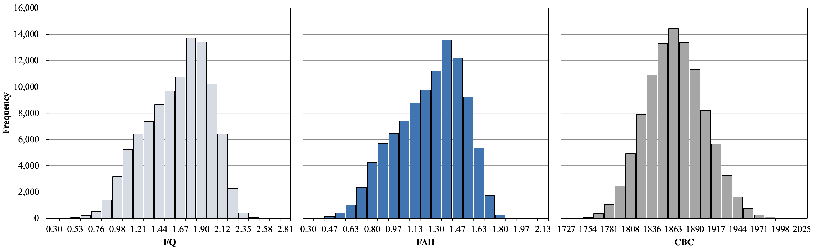

**Fig. 3:** Normal distribution analysis for FQ, F∆H, and CBC.

The frequencies of the parameters within interval (µ-σ, µ+σ) are all around 0.67, those within interval (µ-2σ, µ+2σ) are all around 0.96, and those within interval (µ-3σ, µ+3σ) are all greater than 0.999. Figure presents the distributions of FQ, F∆H, and CBC. These frequencies show trends overall closely resemble the theoretical probabilities of a normal distribution, namely 0.682, 0.955, and 0.997. The normal distribution plot of FQ and F∆H shows similar characteristic of skewness. In most cases, FQ and F∆H values of PWRs are with low variance. This is because the symmetrical arrangement of fuel assemblies results in a relatively flat power distribution. The normal distribution shown in the figures hereby also conforms to physics laws. Therefore, the outputs essentially follow a normal distribution, and the quality of the dataset is suitable for training neural networks.